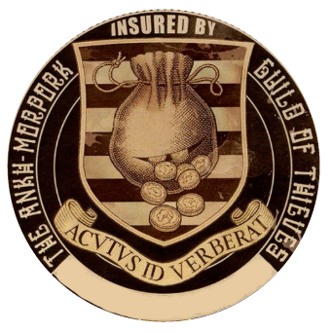

This document is proof that the holder

________________________________

Has paid premiums to the Ankh-Morpork Guild of Thieves for the year of the Meandering Stoat.

The holder is hereby insured against the muggings, burglary, licenced pickpocketing and general thievery from Guild Members.

For theft based activity from non-guild members please report said perpetrators to the Guild so that Guild representatives may ensure the removal of said thieves’ existence.

